Damerham Tea and Chat
The Tea and Chat group meets on the first Wednesday of each month at The Village Hall at 2pm. This group has been running since around 1997 with several changes of organisers. Currently Ella Whitcher and Jenny Ragg head up the group with a small dedicated committee to help.
The group is open to any adults but mainly consists of older folk. We arrange a program for the whole year with various activities and speakers.
We have an ongoing connection with the Western Downland School Year 2 children in Maple Class and Mrs Kirkcaldy. The children first meet us in December when they come to perform their nativity play to us. They come again around Easter time to play a game of bird bingo and then finally at our June meeting, which is our Strawberry Cream Tea. Each child is assigned a willing adult to be their pen pal for the year.
We have a lovely group of people from Damerham and the surrounding areas who enjoy getting together, eating sandwiches and cake and joining in with the program. The majority of those who are able are on the rota to take a turn providing the refreshments and serving them on the day. We have some amazing cake bakers amongst our group.
We organise 3 outings during the year which are well attended. If there is space on the coach then we open the trip up to others to come. We also go out for a Christmas meal.
The cost of Tea and Chat is £1 per month. We do have a membership scheme which then entitles the member to a discount for the outings and a subsidy at the Christmas Meal but there is no obligation to become a member. The membership is £10 per year payable in two instalments in January and July.
Each month we have a raffle where everybody who wishes to buy a ticket for £1 brings an item to put on the raffle table. This way everyone goes home with a small item. Items are usually tins of food, sweets, home grown produce, plants, toiletries, small gifts etc
Our main fundraisers for the group are a Jumble Sale in January at the Hall and a stall at the Village Fair in July on the Sports Field.
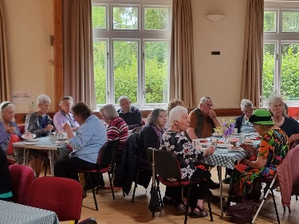
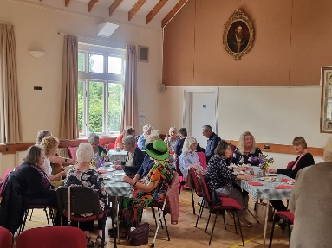
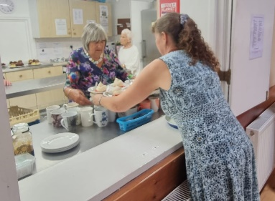
If you have any questions please contact Ella ellawhitcher@hotmail.co.uk or 07986 650123.

